Order Of Service

Singing: Psalm 118—CW page 108

Reading: Psalm 52

Opening Hymn: TLH 23

Reading: Acts 4:32-37

Request Hymn: CW Supplement 735

Reading: John 12:20-26

Sermon Hymn: TLH 39

Sermon Text: Song Of Solomon 8:1

As My Brother

Prayer

The Apostles’ Creed, TLH page 12

Holy Communion

The Lord's Prayer

The Blessing

Closing Hymn: TLH 45

* * * * * * * * * * *

Bible Study: Lambs: The Dandelion
Sheep: Romans 3:21-31


Mountain of Glory

Water
Of
Life

27 August 2017

W A T E R O F L I F E

Independent Christian Church—Conservative Lutheran Doctrine

Worship Service: 9:30 a.m. Bible Study: 10:45 a.m.

Larry Cooper, Pastor E-Mail address:
111 N. Ridge Road lcooper@wateroflife.cc
Coon Valley, WI 54623 Web Site:
Phone: (608) 452-2105 www.wateroflife.cc

* * * * * * * * * * * * * * * * * * * * * * * * * * *

Sermon Text: Song Of Solomon 8:1

As My Brother!

* * * * * * * * * * * * * * * * * * * * * * * * * * *

Song of Solomon 8:1 O that thou wert as my brother, that sucked the breasts of my mother! when I should find thee without, I would kiss thee; yea, I should not be despised.

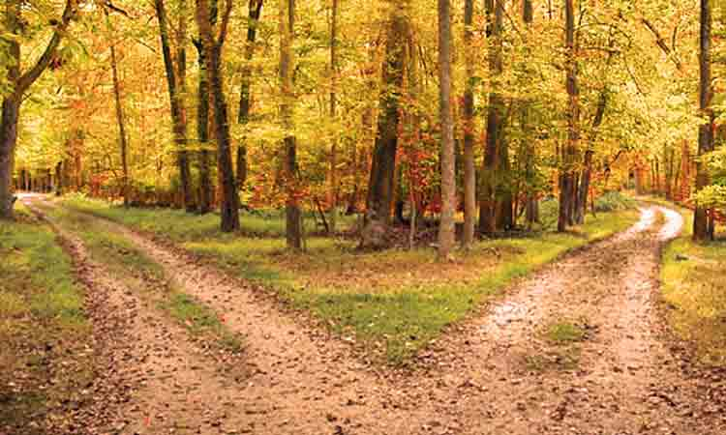
The Road Not Taken

Two roads diverged in a yellow wood
And sorry I could not travel both
And be one traveler, long I stood
And looked down one as far as I could
To where it bent in the undergrowth;

Then took the other, as just as fair,
And having perhaps the better claim,
Because it was grassy and wanted wear;
Though as for that the passing there
Had worn them really about the same,

And both that morning equally lay
In leaves no step had trodden black.
Oh, I kept the first for another day!
Yet knowing how way leads on to way,
I doubted if I should ever come back.

I shall be telling this with a sigh
Somewhere ages and ages hence:
Two roads diverged in a wood, and I—
I took the one less traveled by,
And that has made all the difference.

Robert Frost

